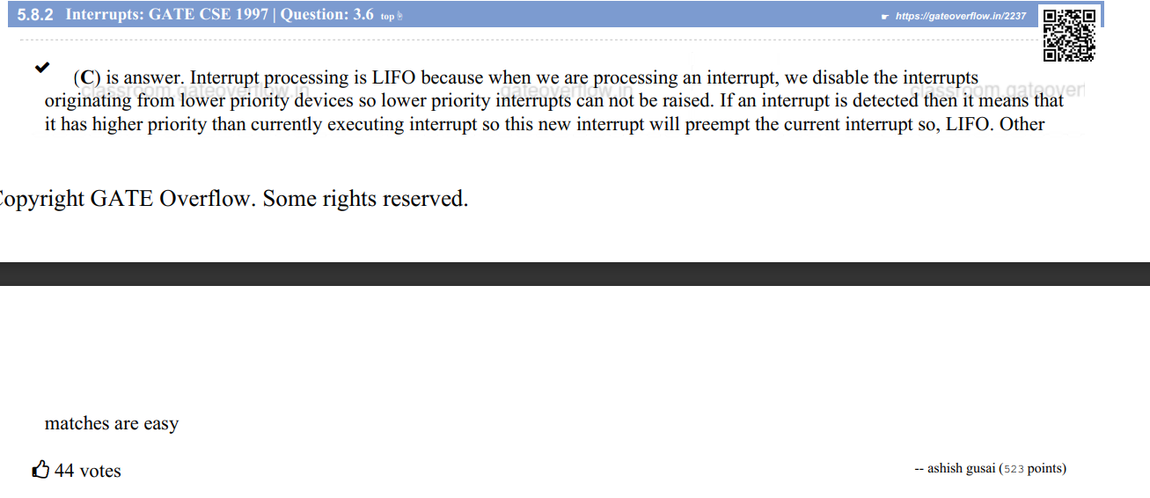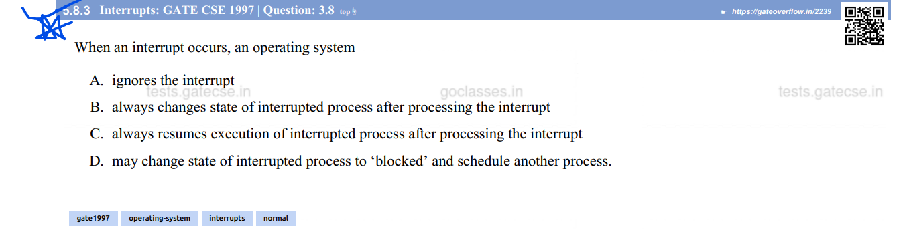

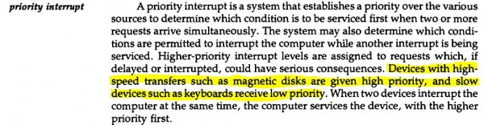

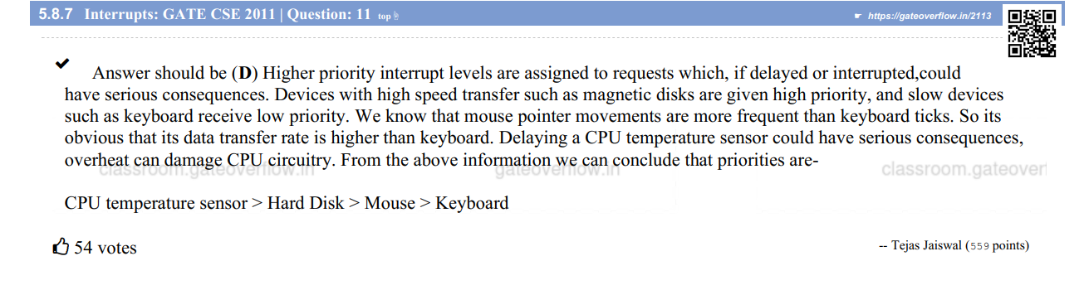

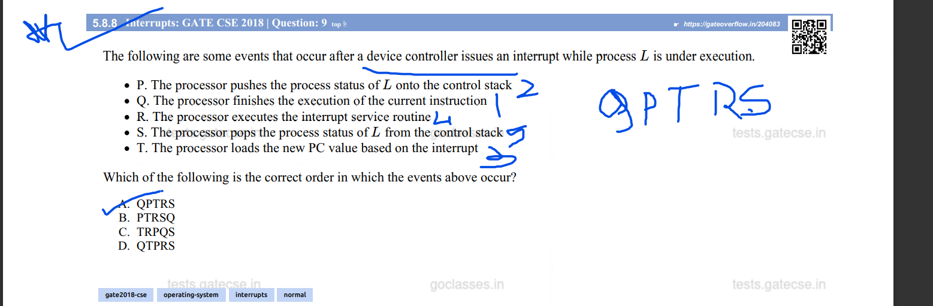

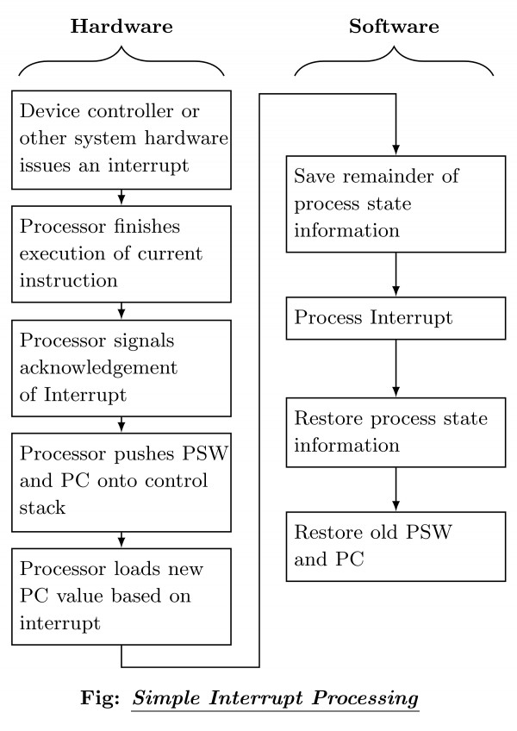

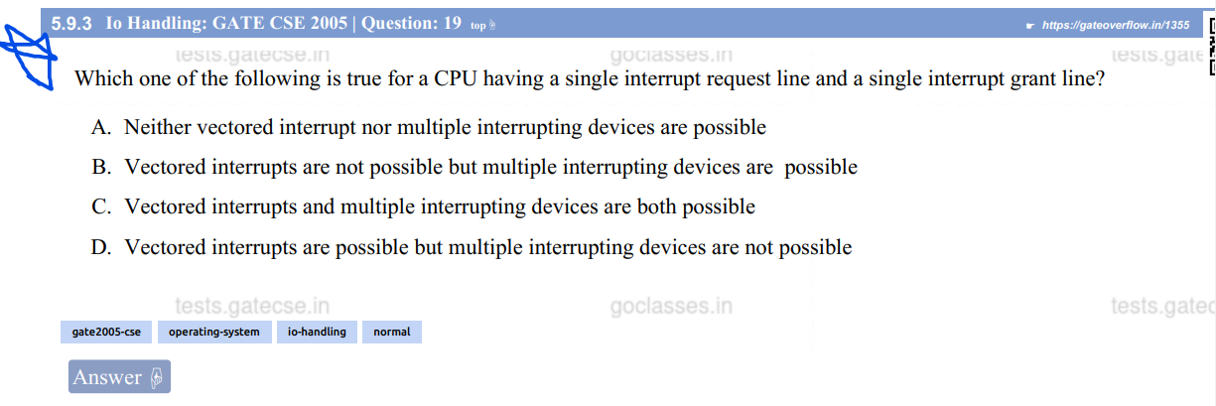

Ans:

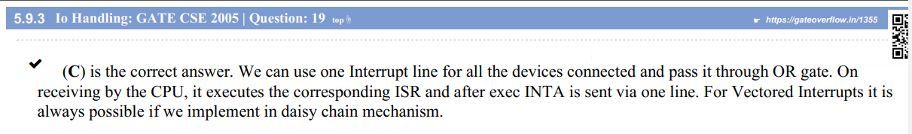



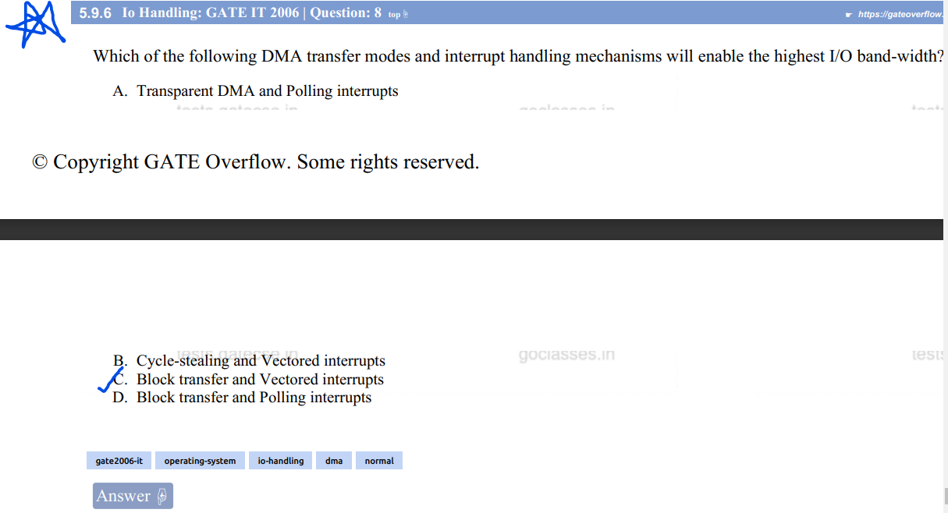

Ans:

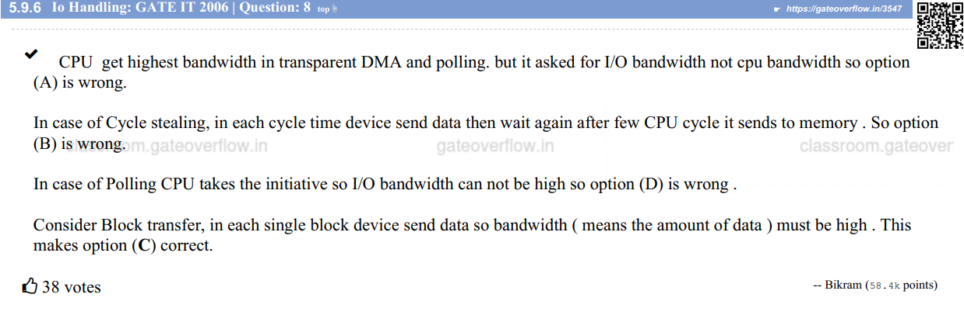

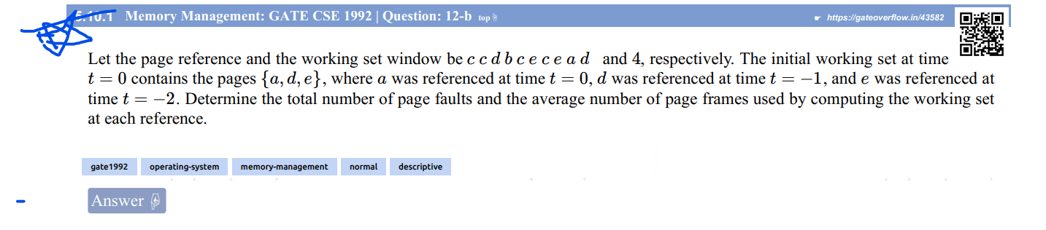

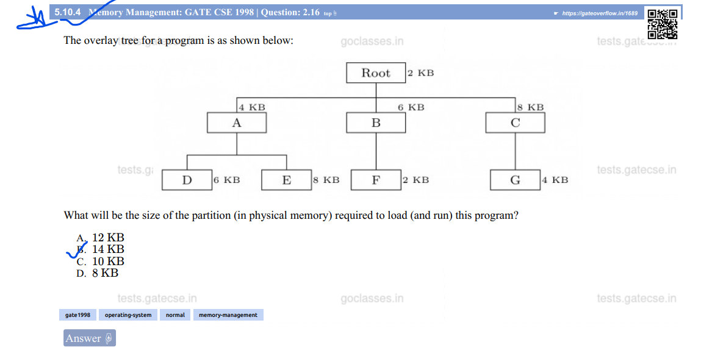

Ans:

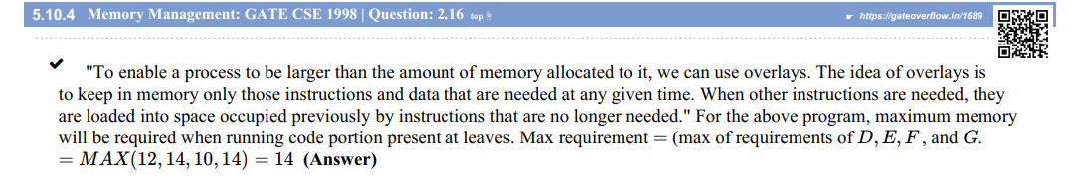

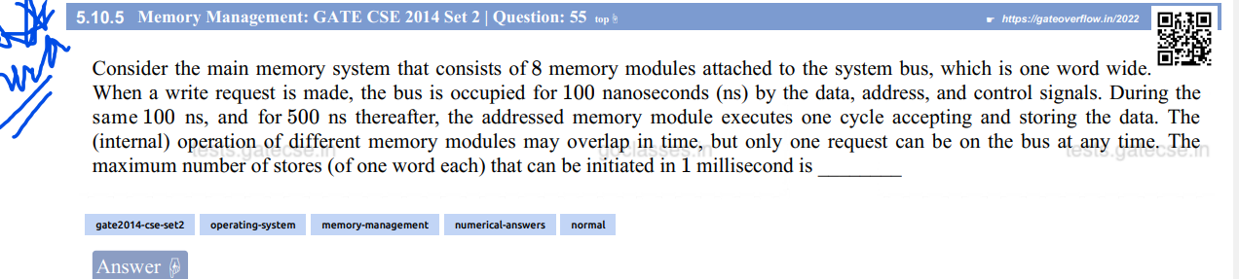

Ans:

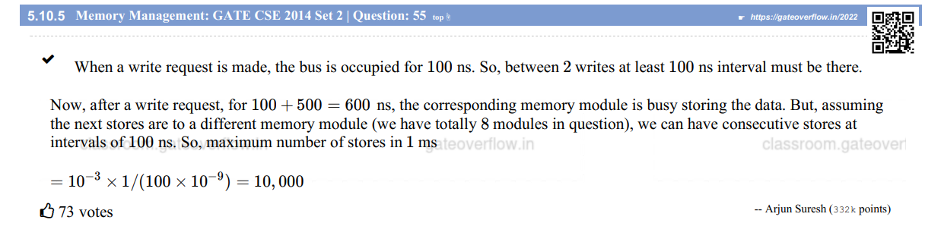

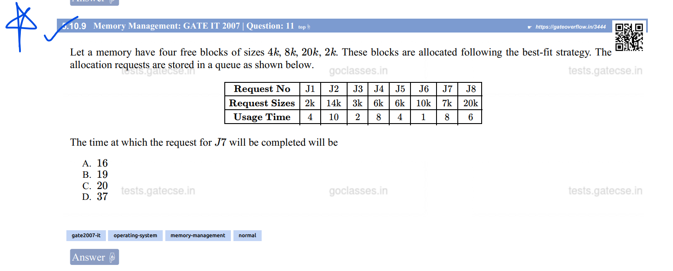

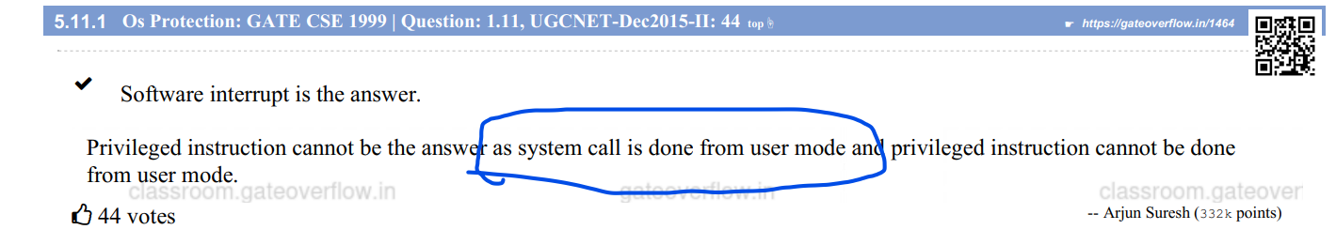

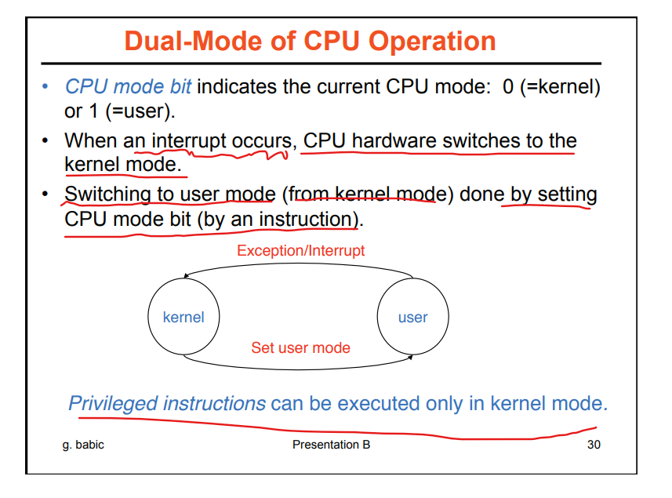

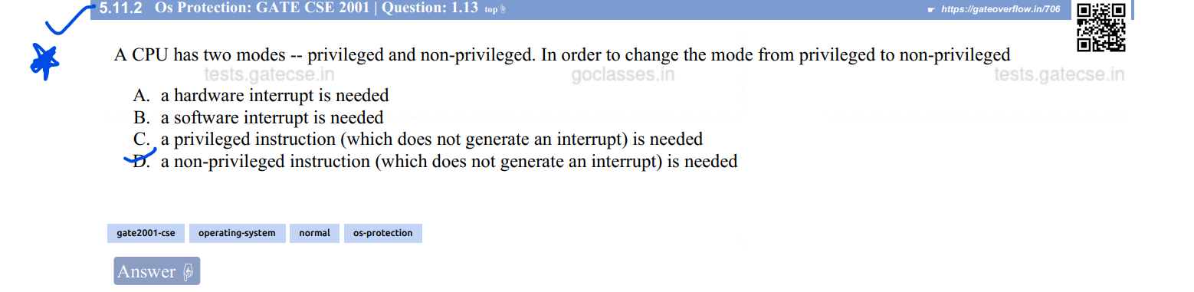

Ans: 

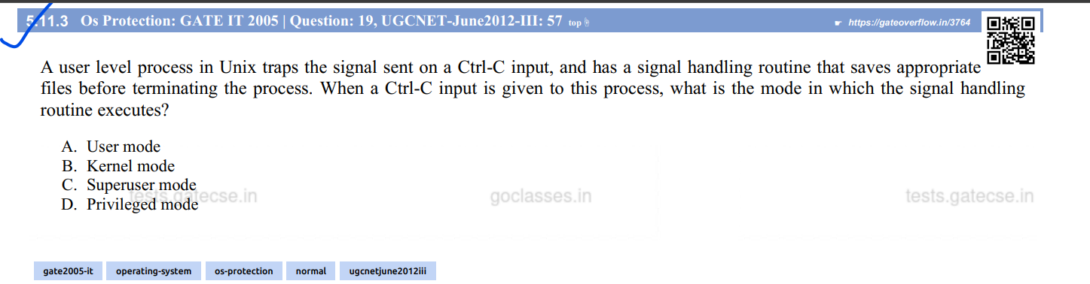

Ans:

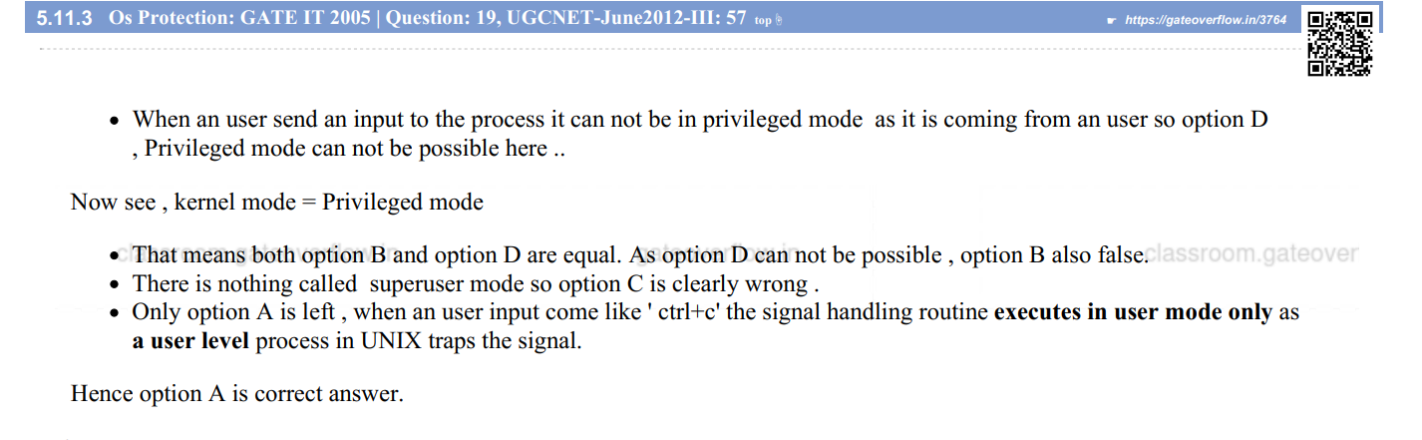

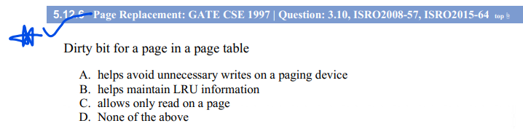

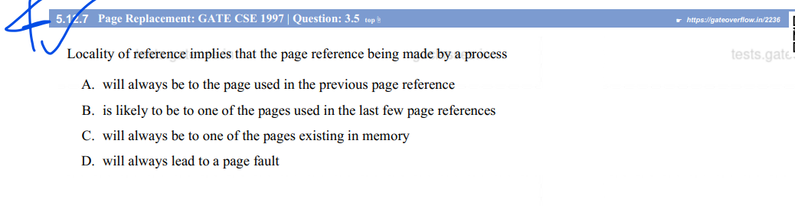

Ans:

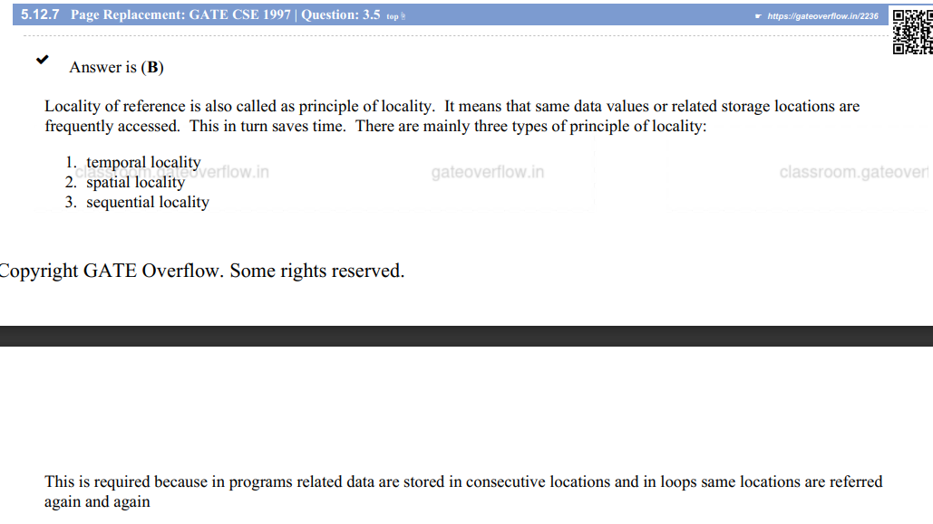

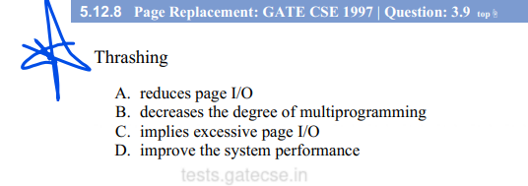

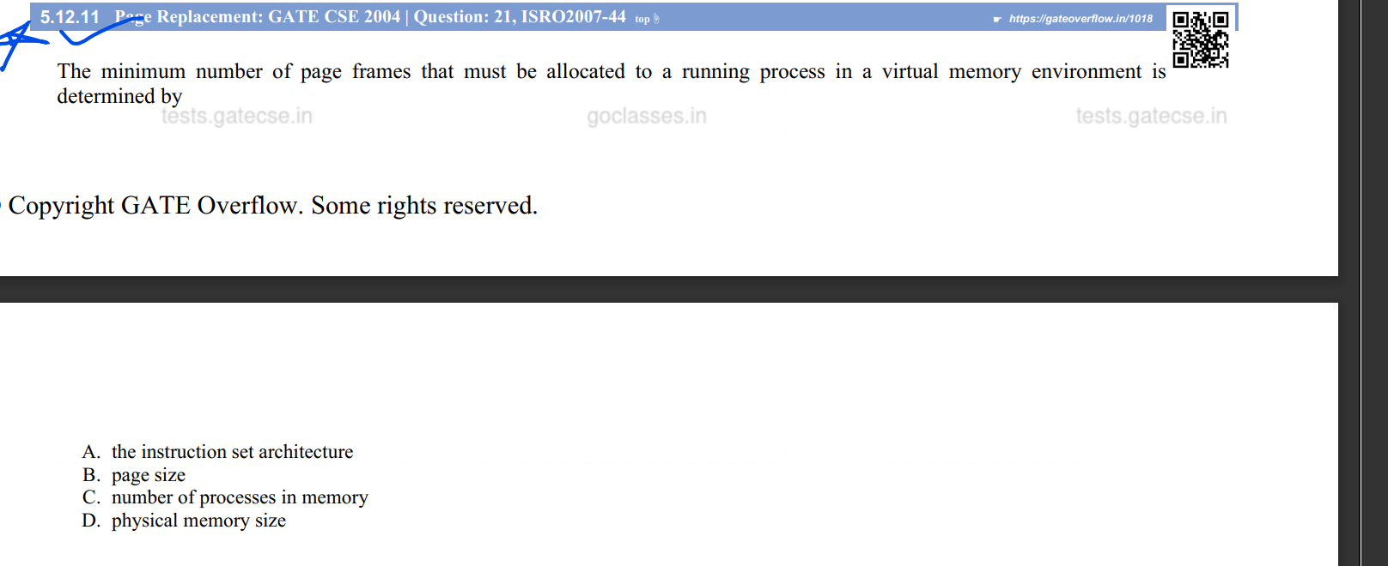

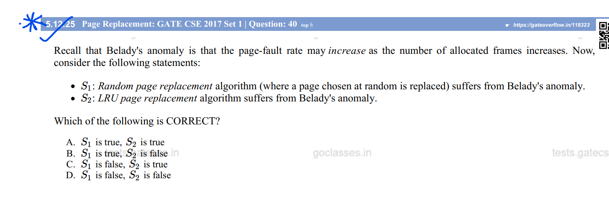

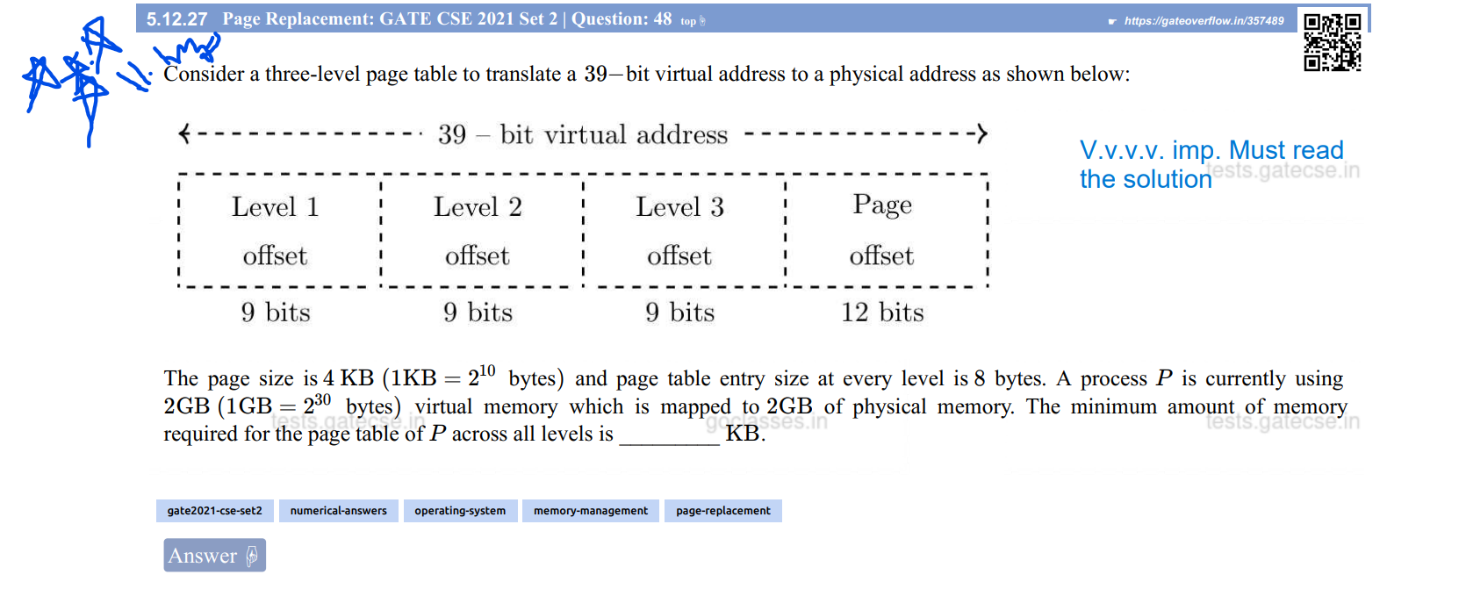  
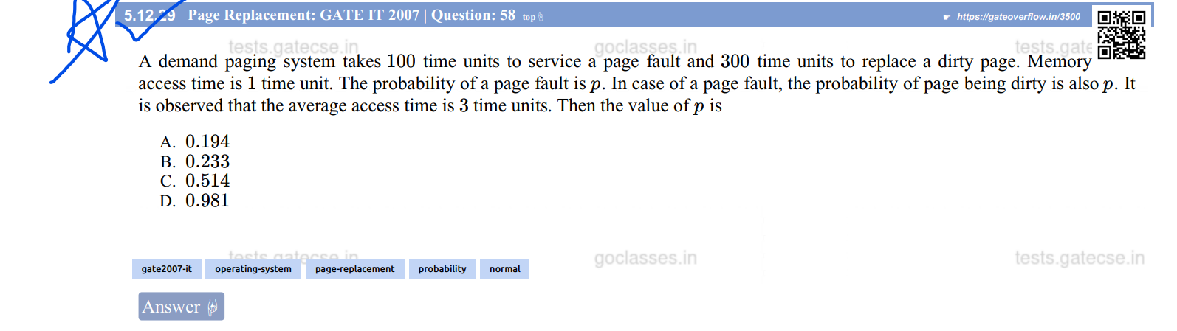

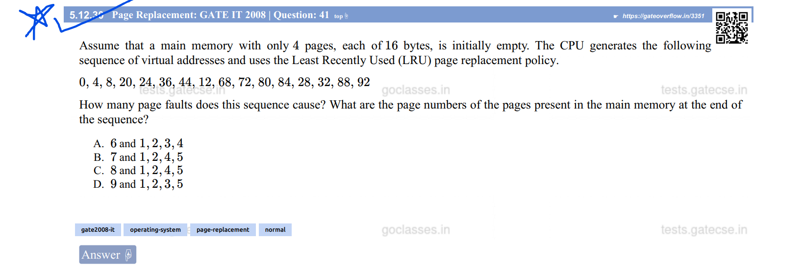

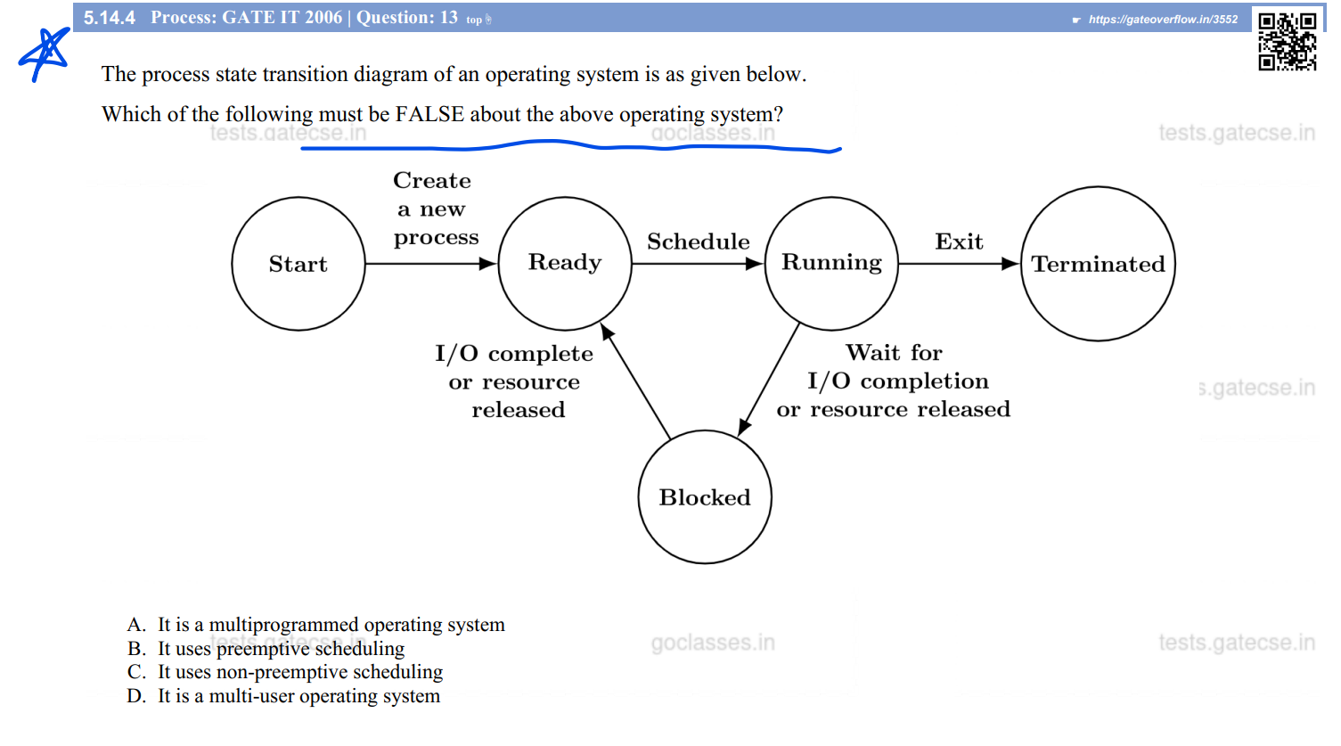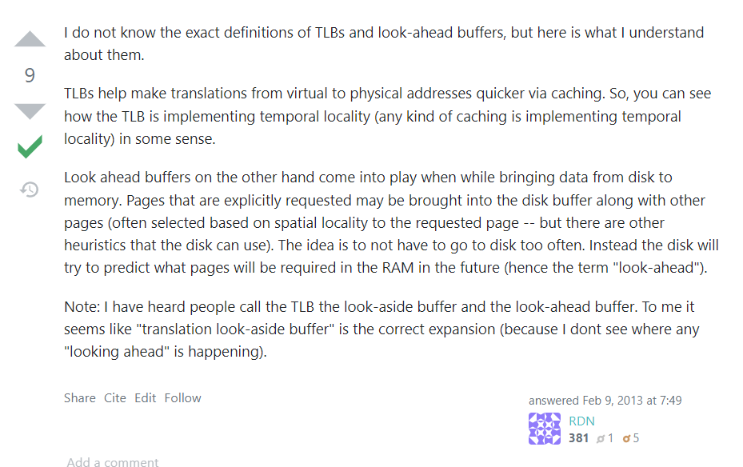

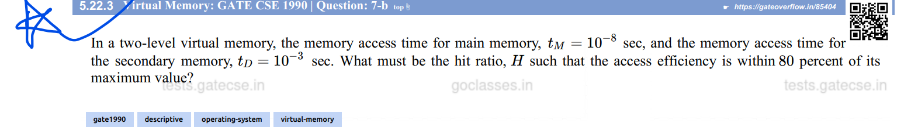

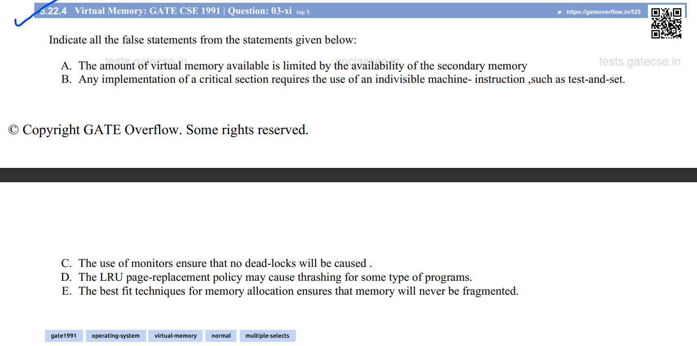

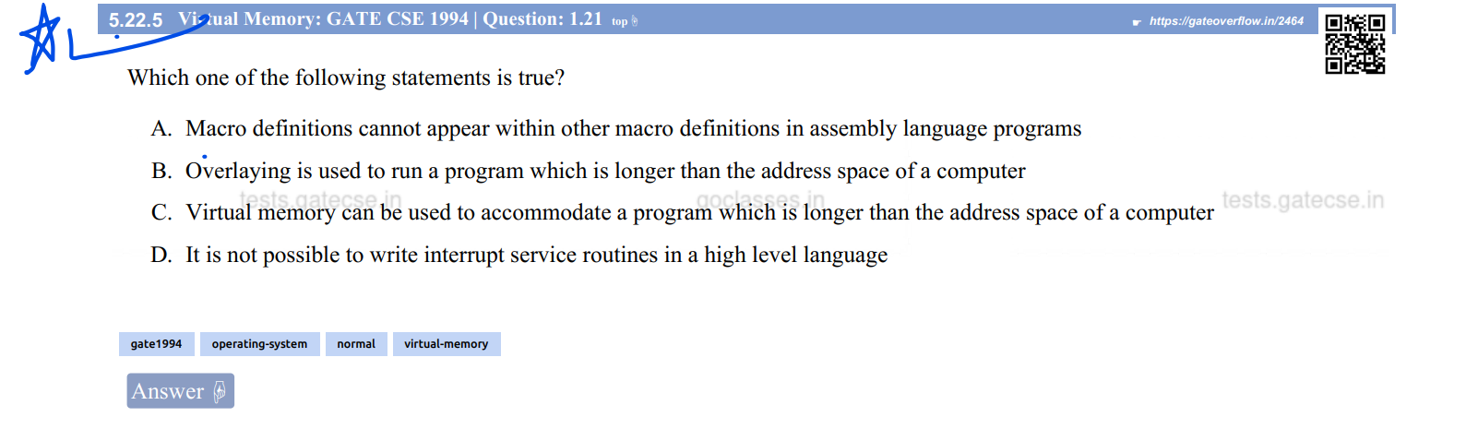

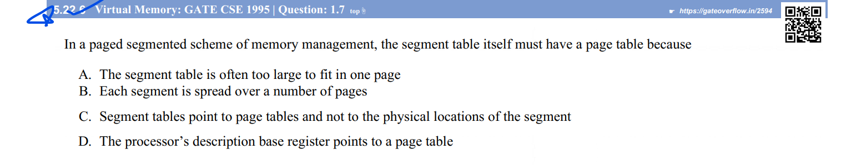

[memory management - Differences or similarities between Segmented paging and Paged segmentation? - Stack Overflow](https://stackoverflow.com/questions/16643180/differences-or-similarities-between-segmented-paging-and-paged-segmentation)

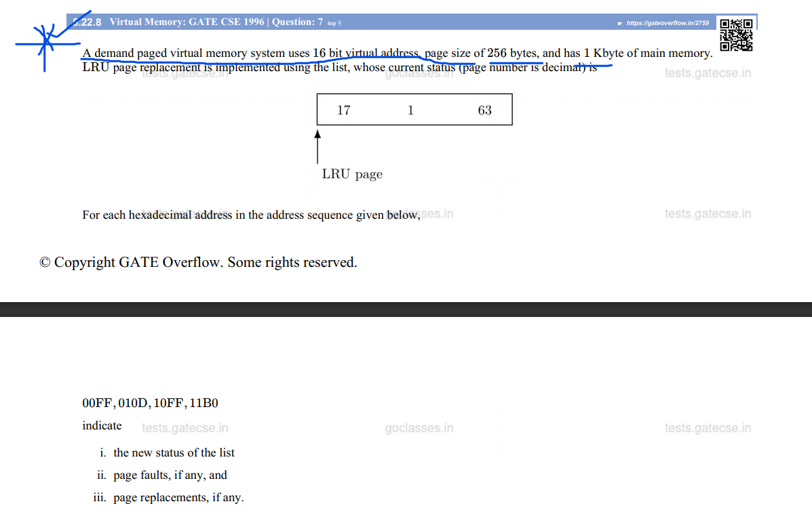

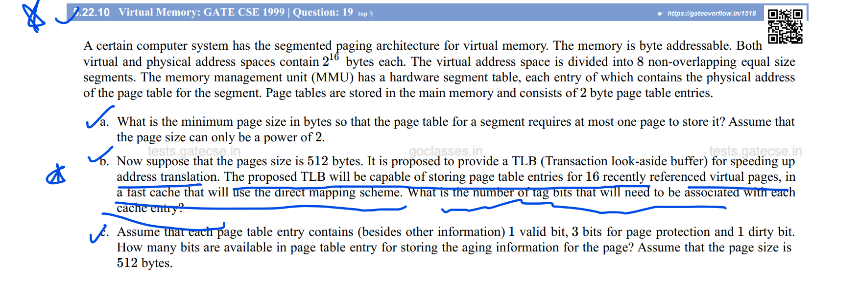

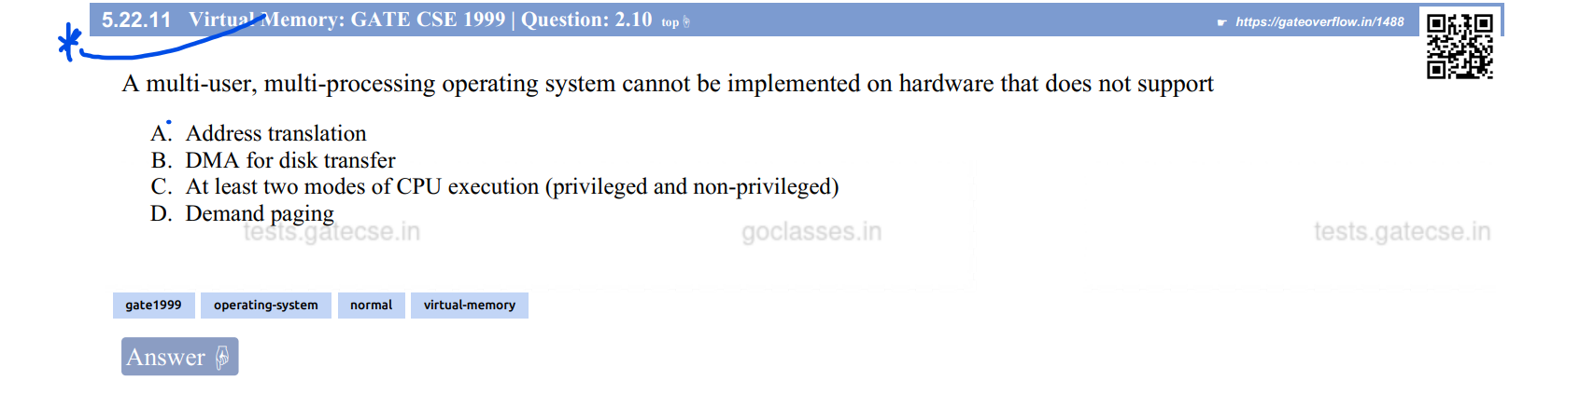

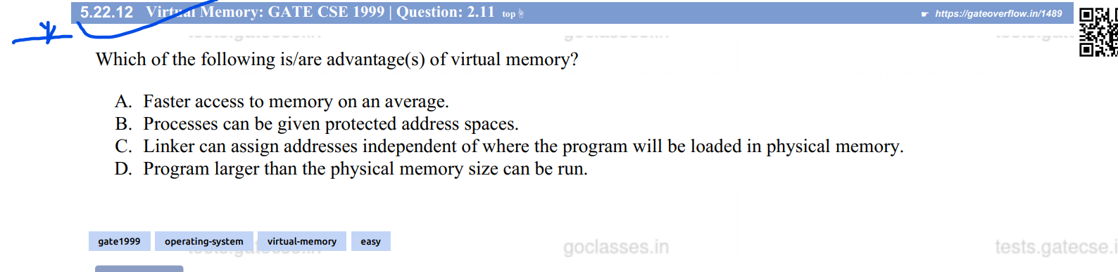

Ans:

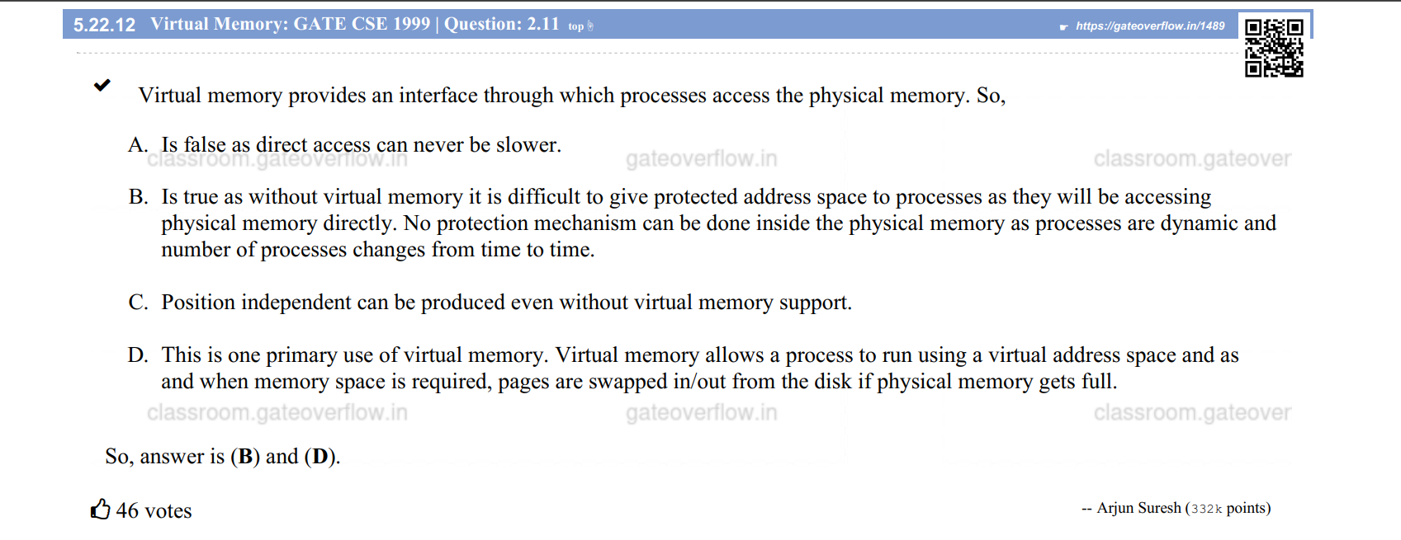

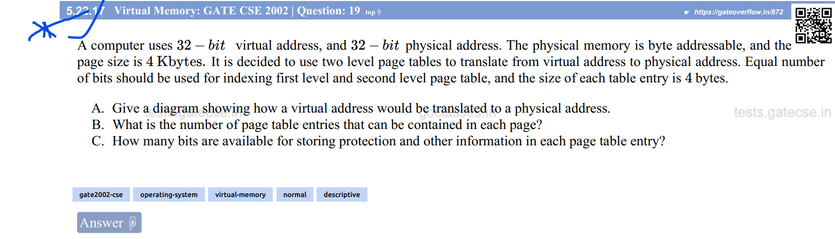Must Do Q:- (See RBR OS- MMgmt vid 52 for solution)

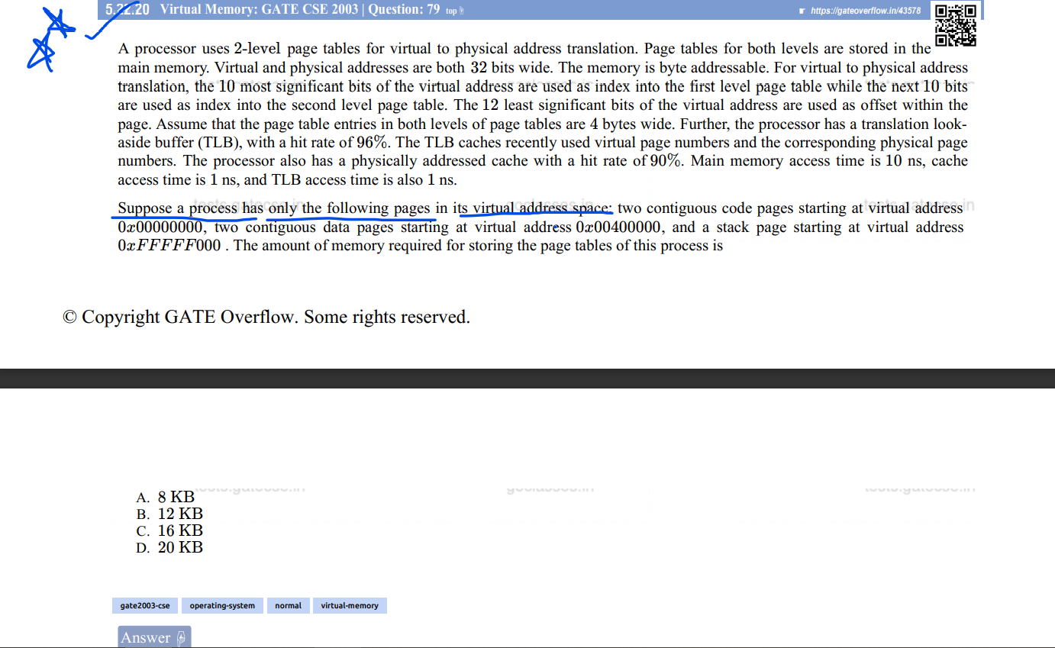

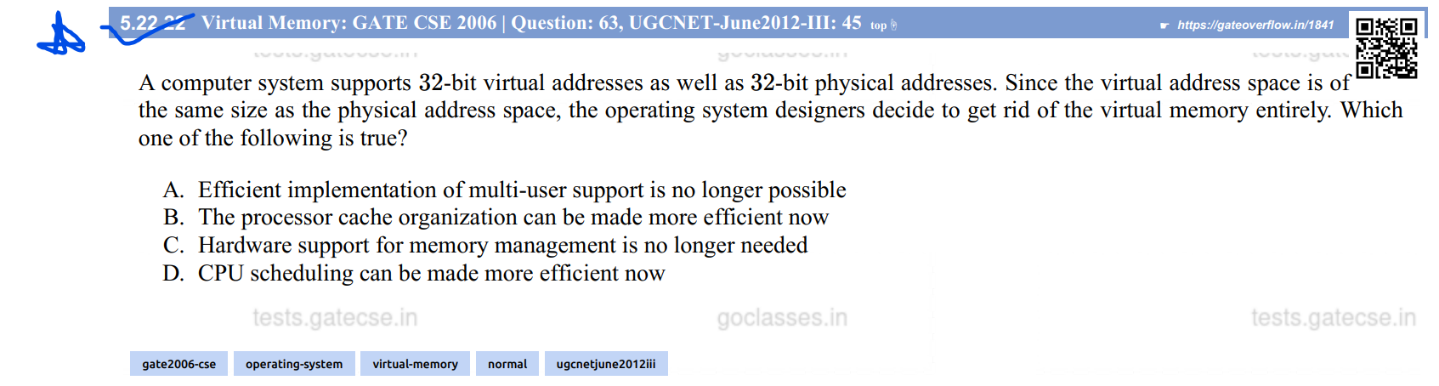

Ans:

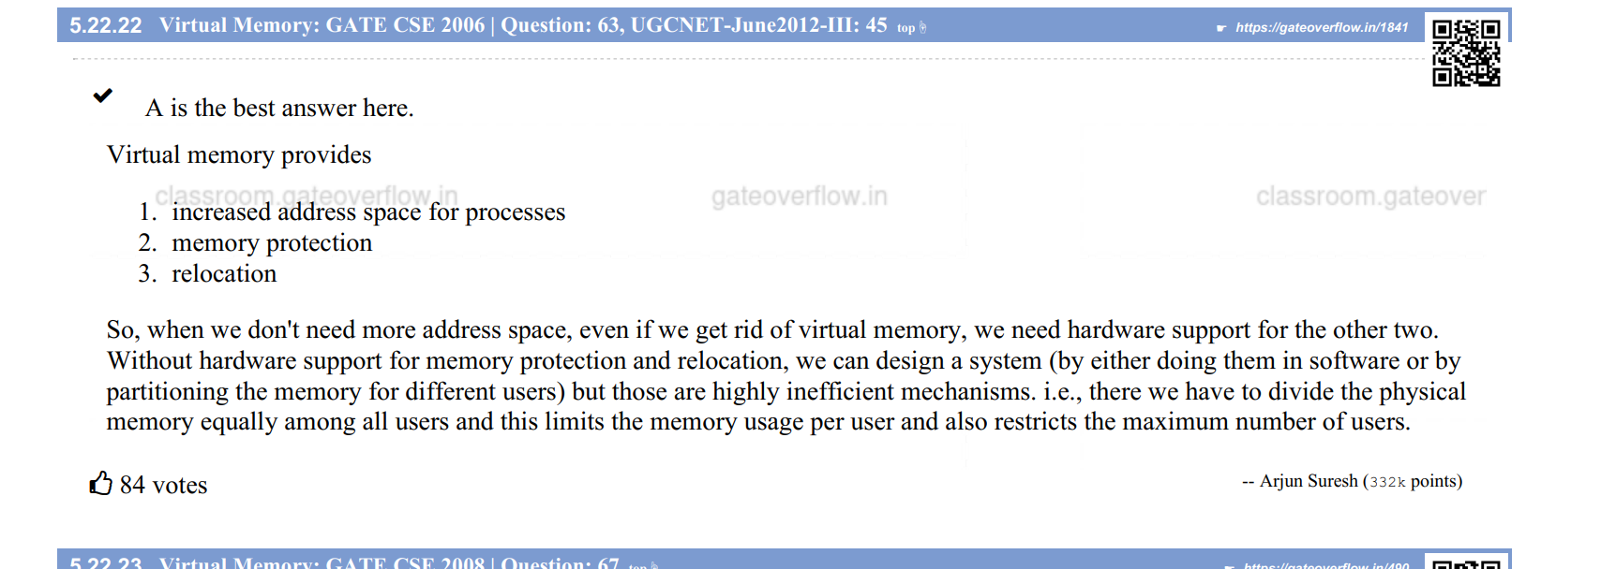

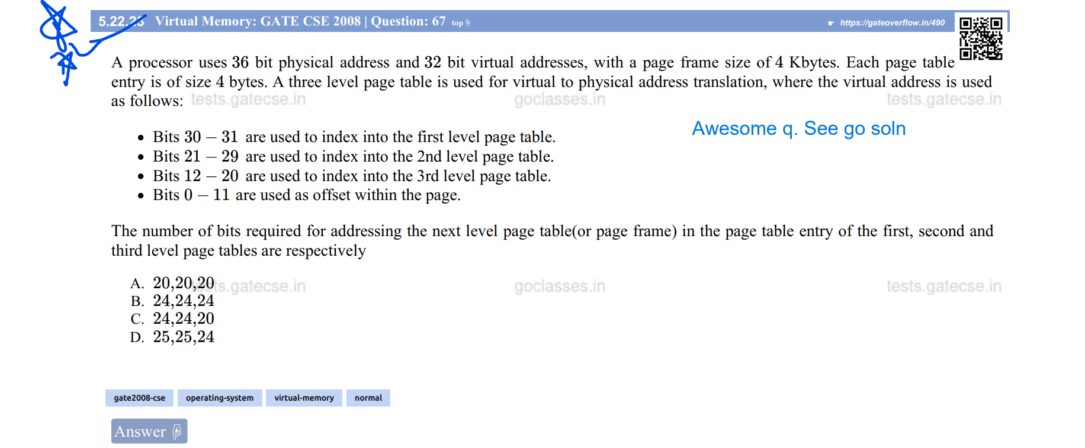

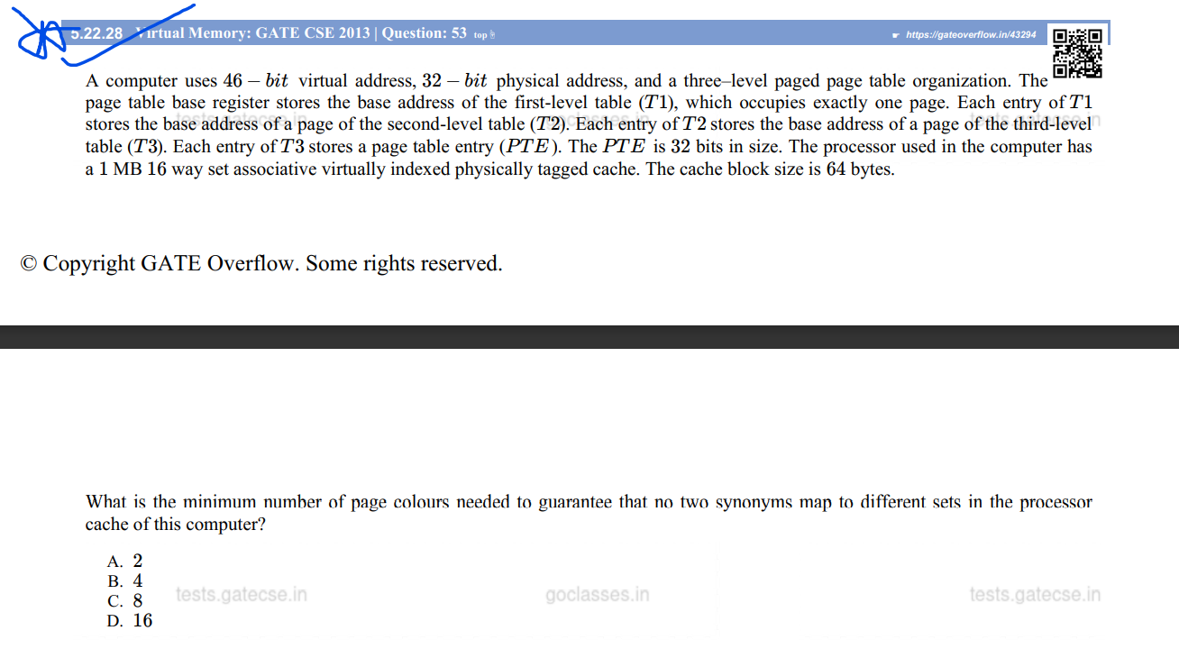

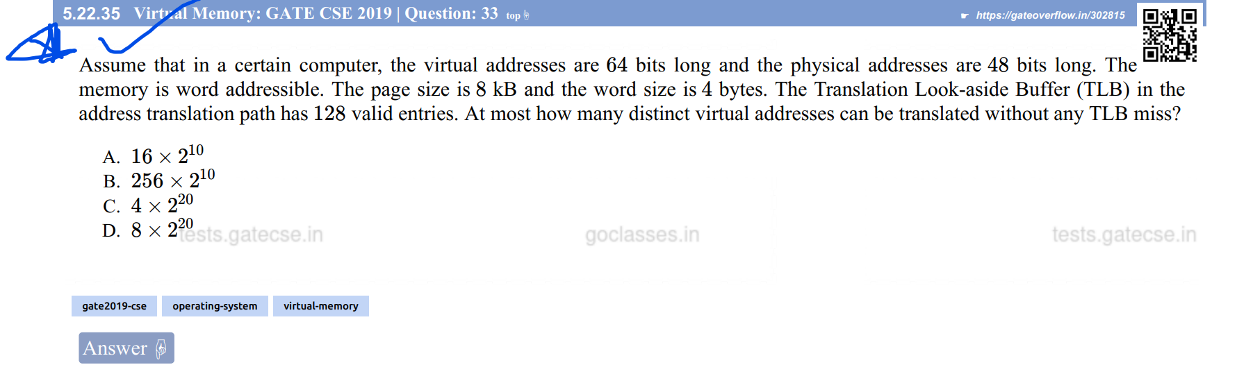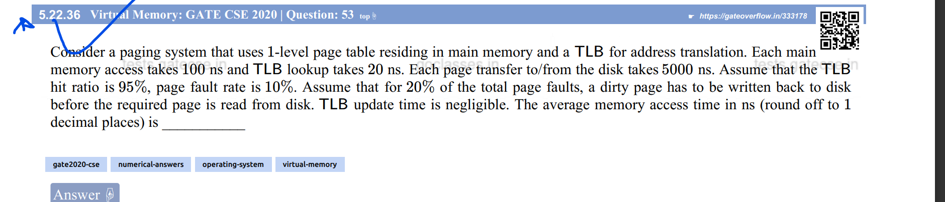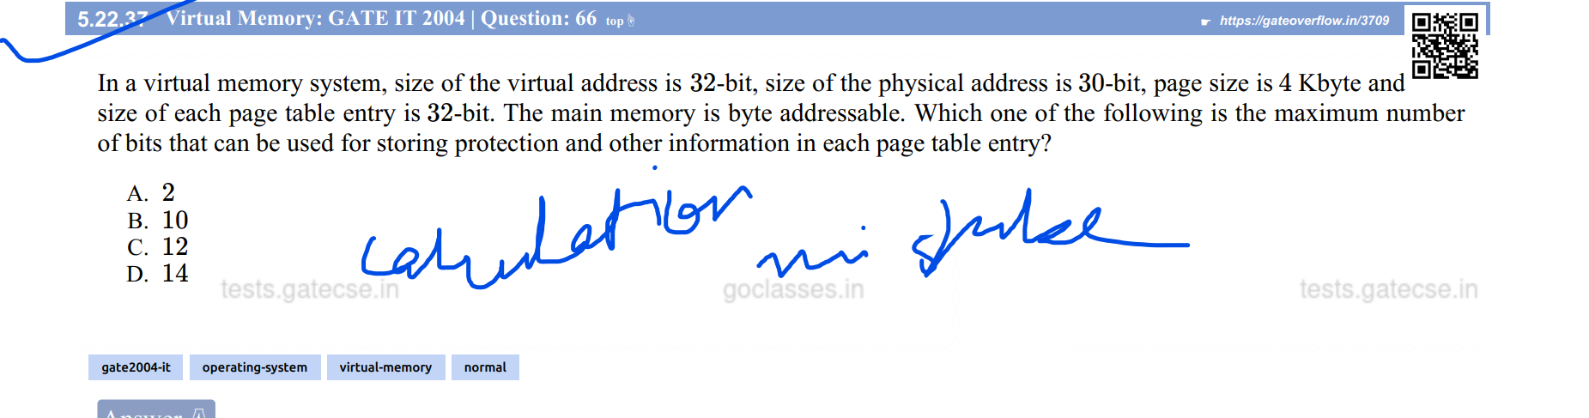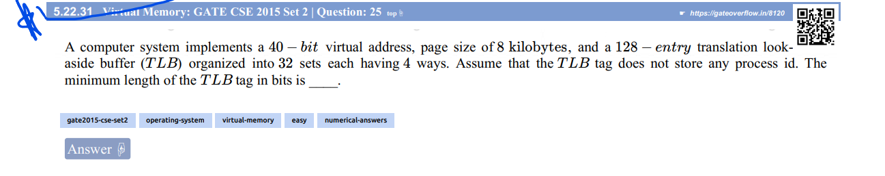

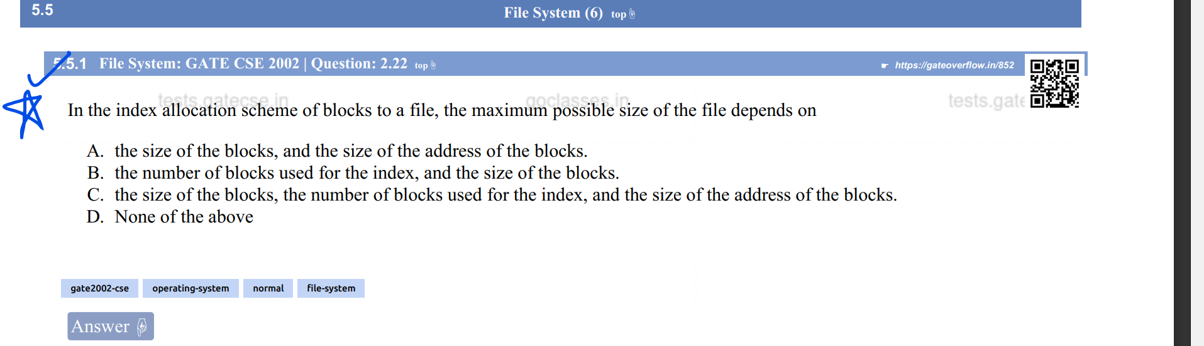

Ans:

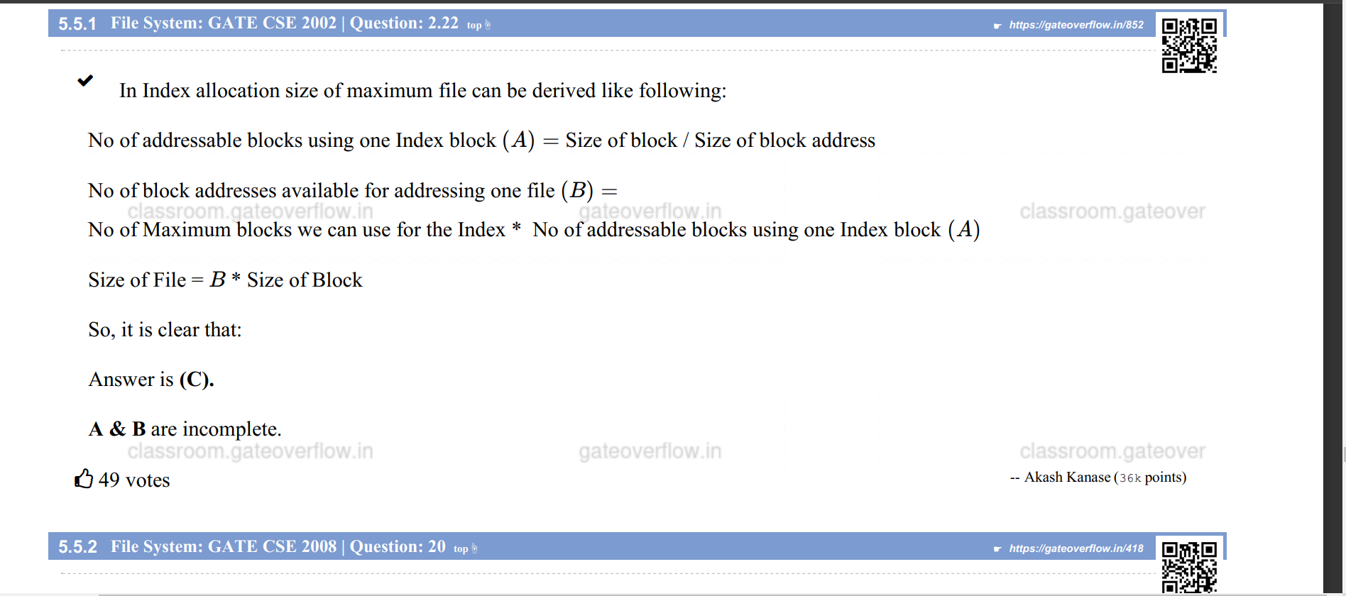



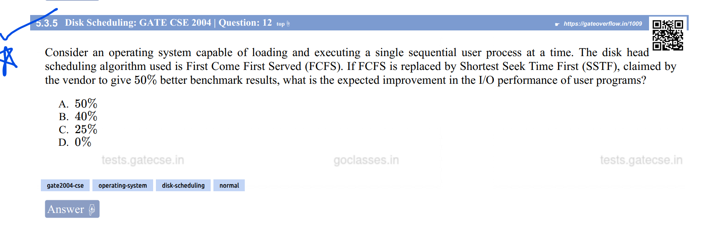

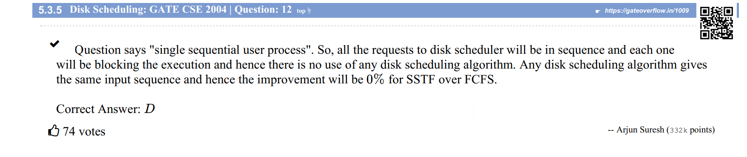

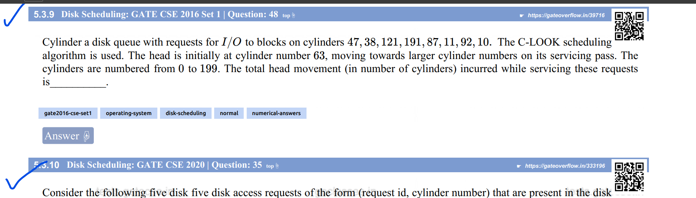

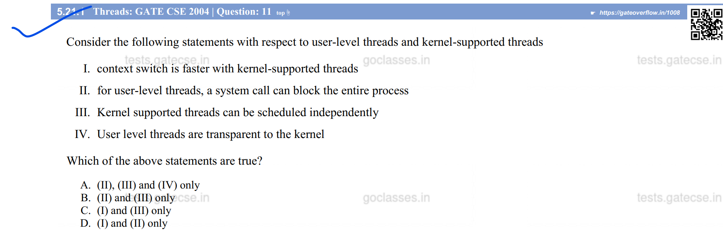

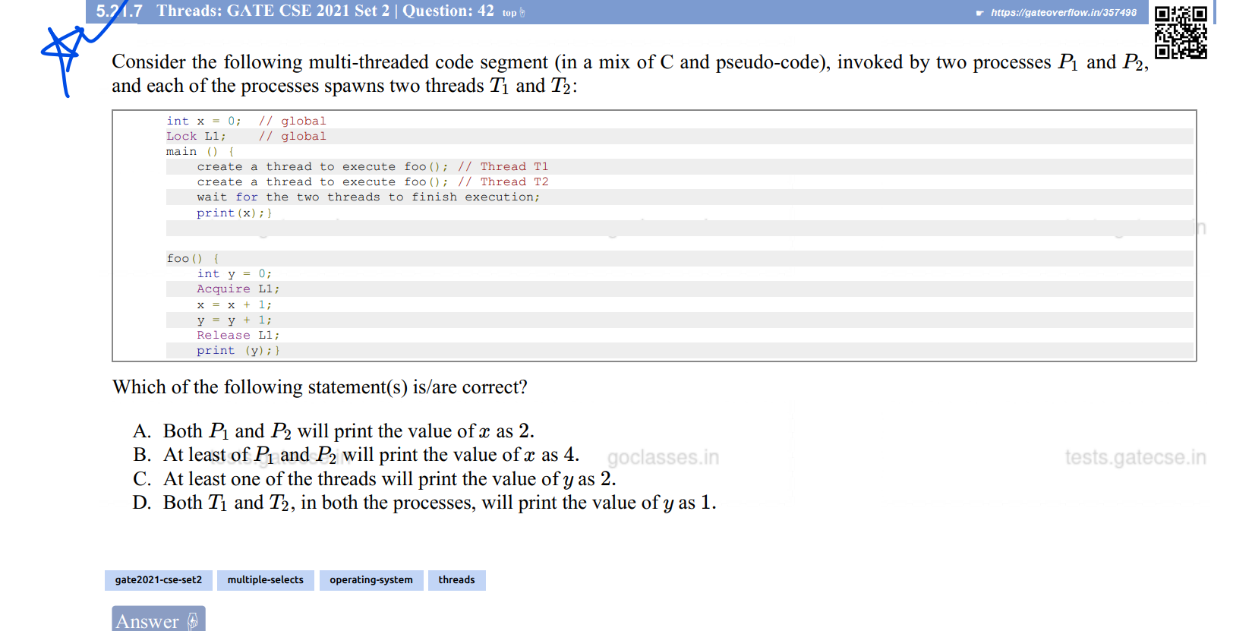

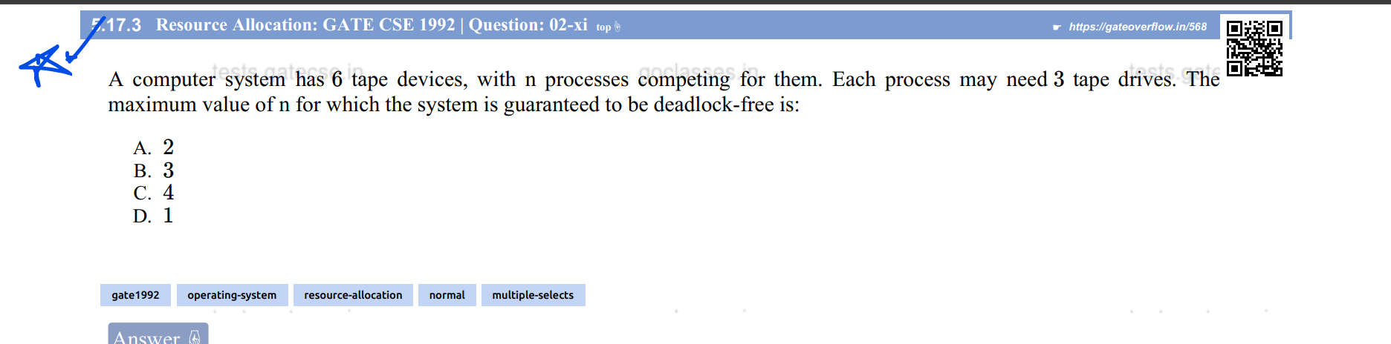

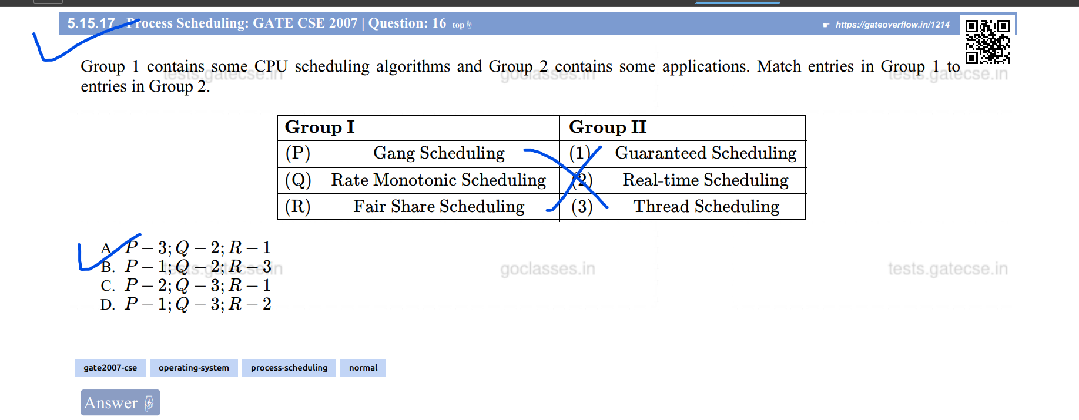

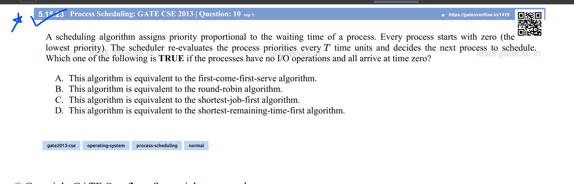

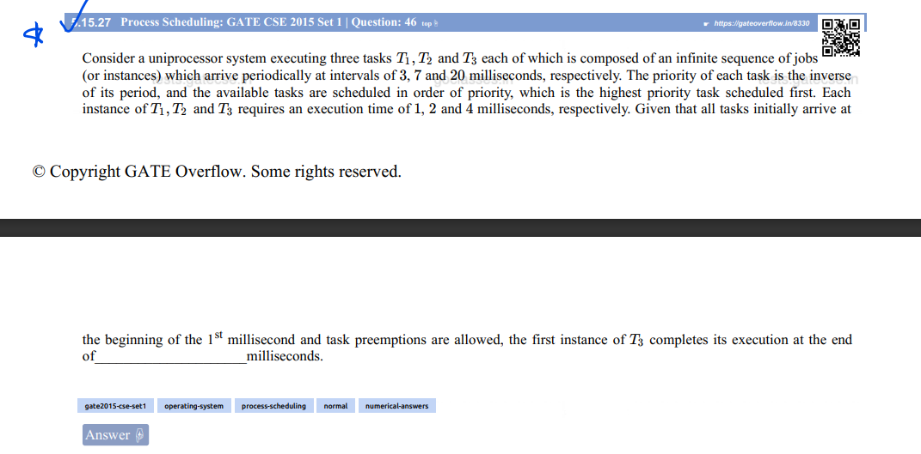

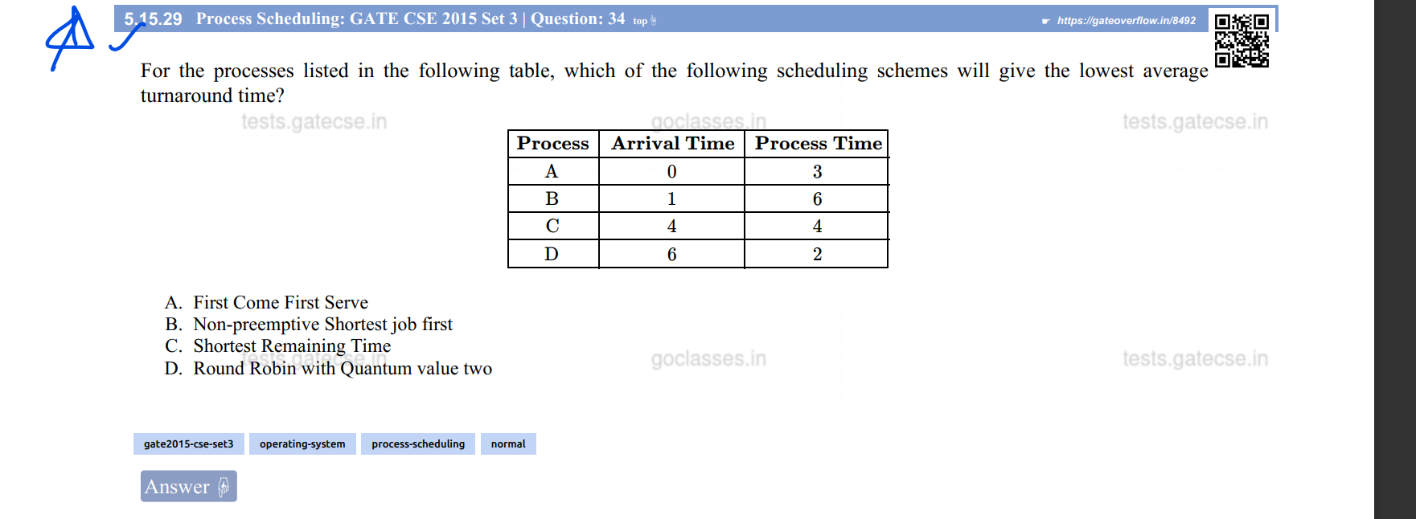

Ans: 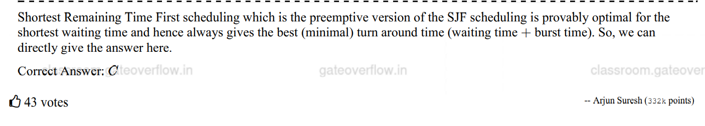

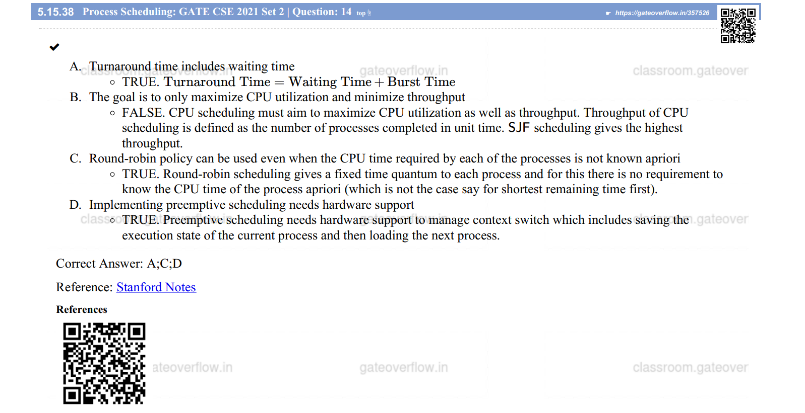

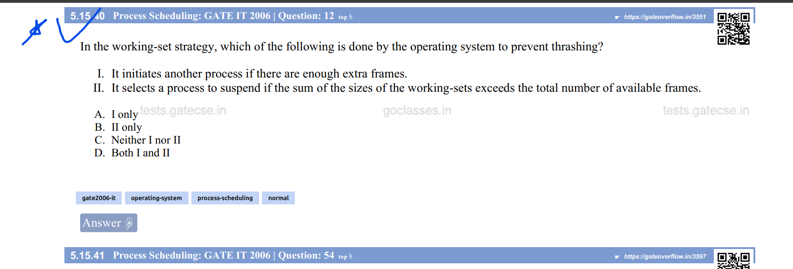

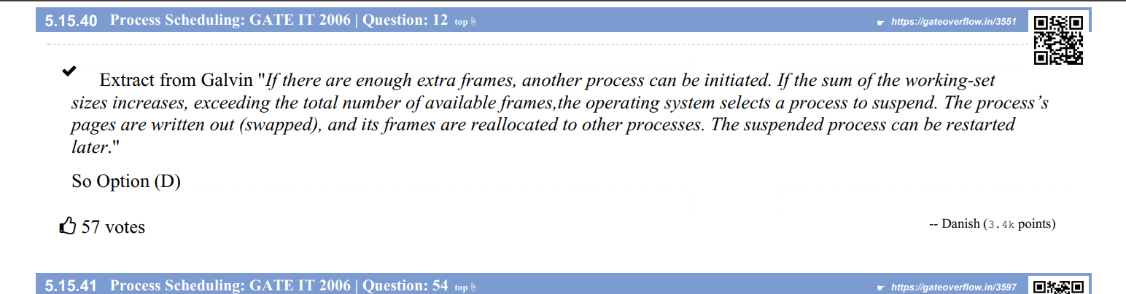

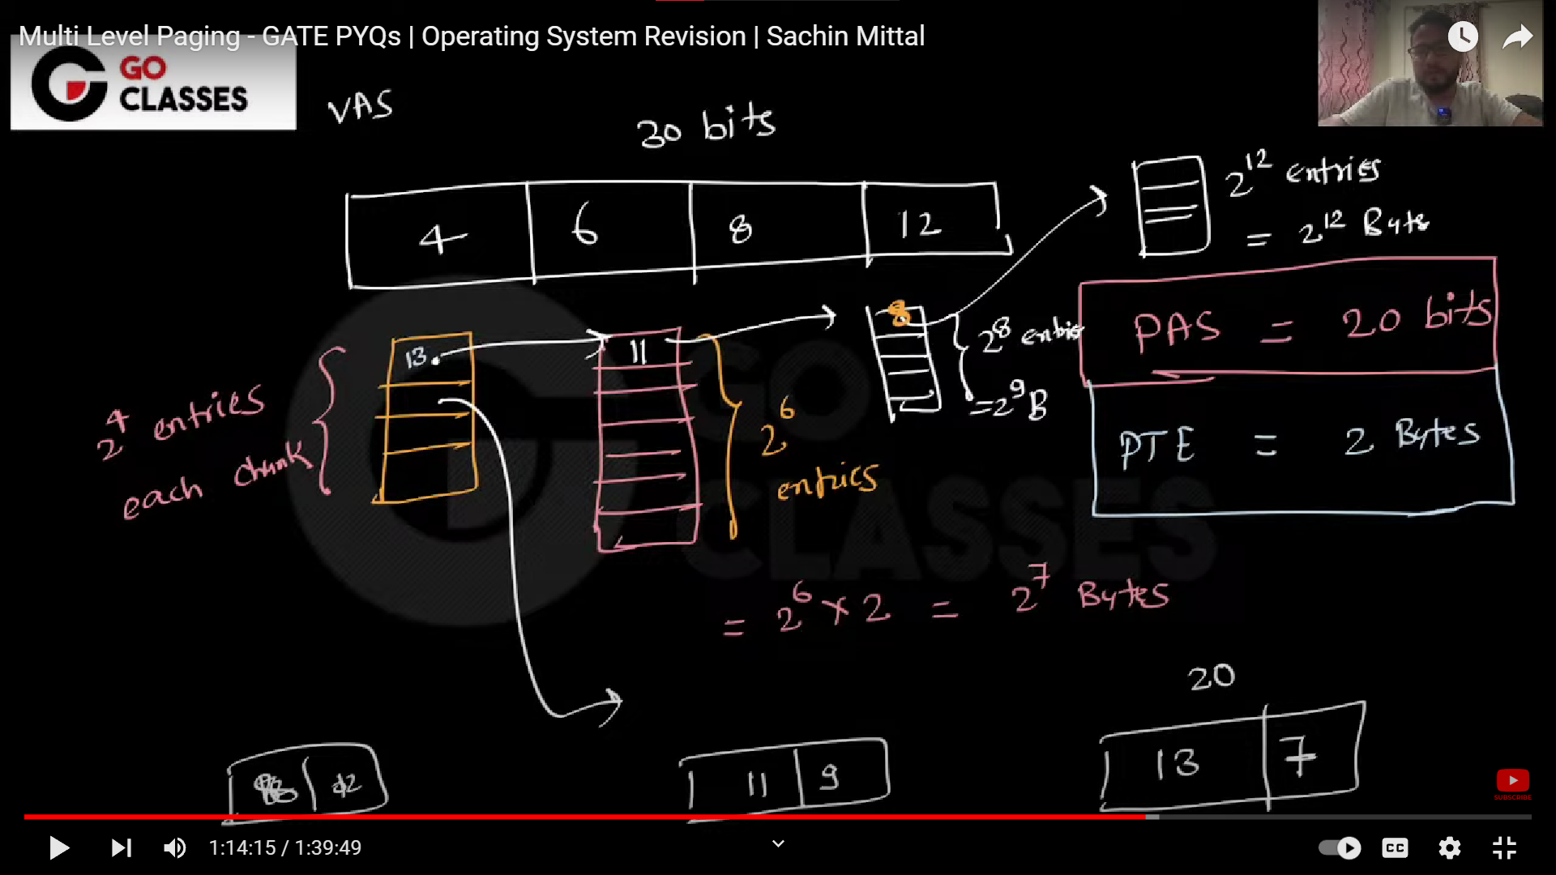

v.v.vimp

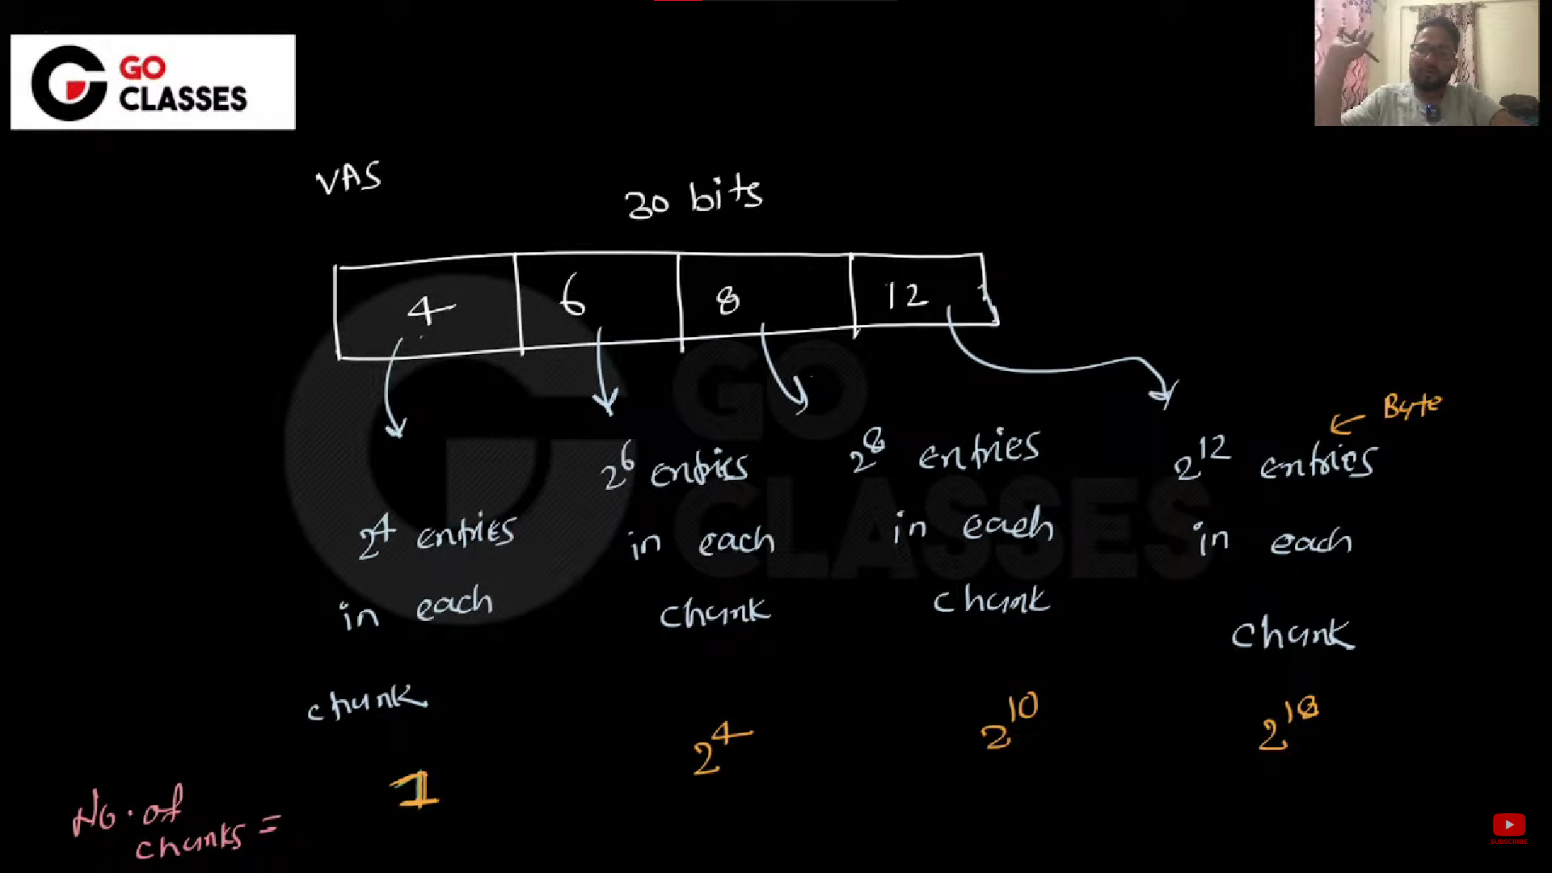

No. of entries in 1st level(where 4 is written) is always = 2^4 entries

No. of chunks in 1st level(where 4 is written) is always = 1 chunk.

No. of entries in 2nd level(where 6 is written) is always = 2^6 entries

No. of chunks in 2nd level(where 6 is written) is always = 2^(Sum of all the previous bits to it in VAS)

= 2^(4) chunks

No. of entries in 3rd level(where 8 is written) is always = 2^8 entries

No. of chunks in 3rd level(where 8 is written) is always = 2^(Sum of all the previous bits to it in VAS)

= 2^(4+6) chunks

= 2^10 chunks

No. of chunks in 4th level(where 12 is written) is always = 2^12 entries

No. of chunks in 4th level(where 12 is written) is always = 2^(Sum of all the previous bits to it in VAS)

= 2^(4+6+8) chunks

= 2^18 chunks

The most important diagram(having the bits for each entry calculation):-

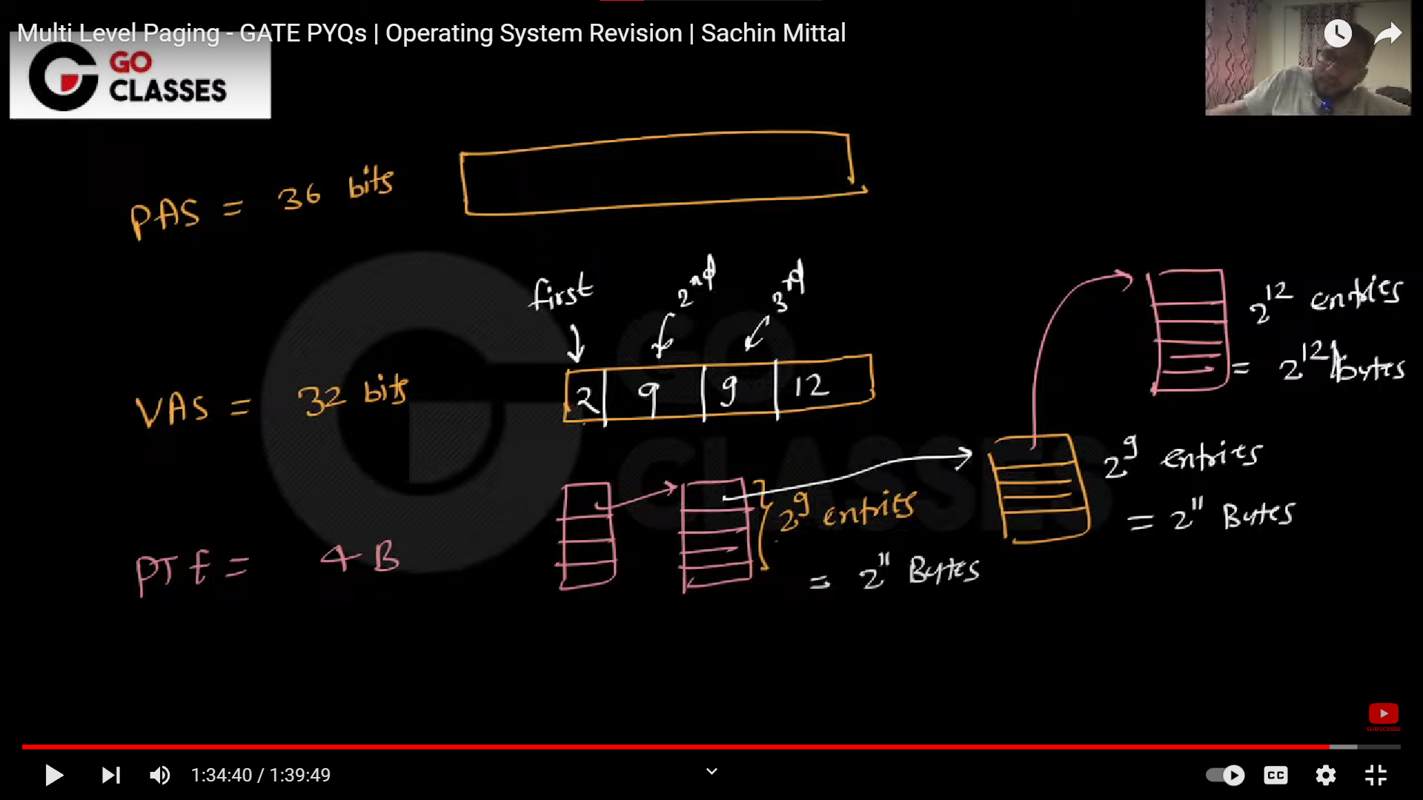

<https://youtu.be/ED3DDOWJ1NE?t=5539> [Watch just 10mins to get more insight]

Q) 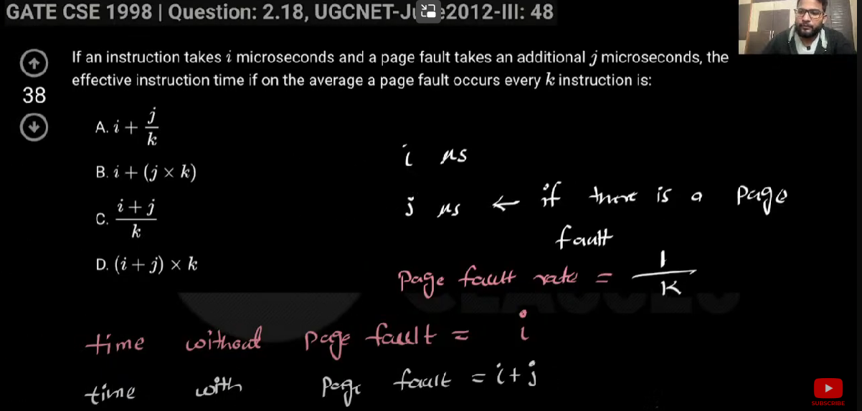

Soln:

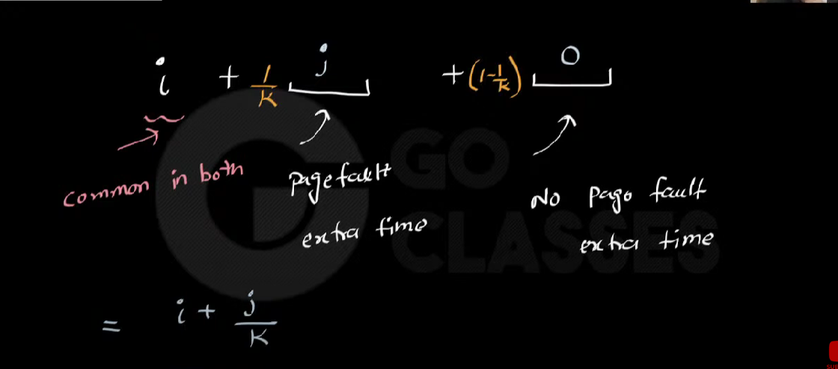

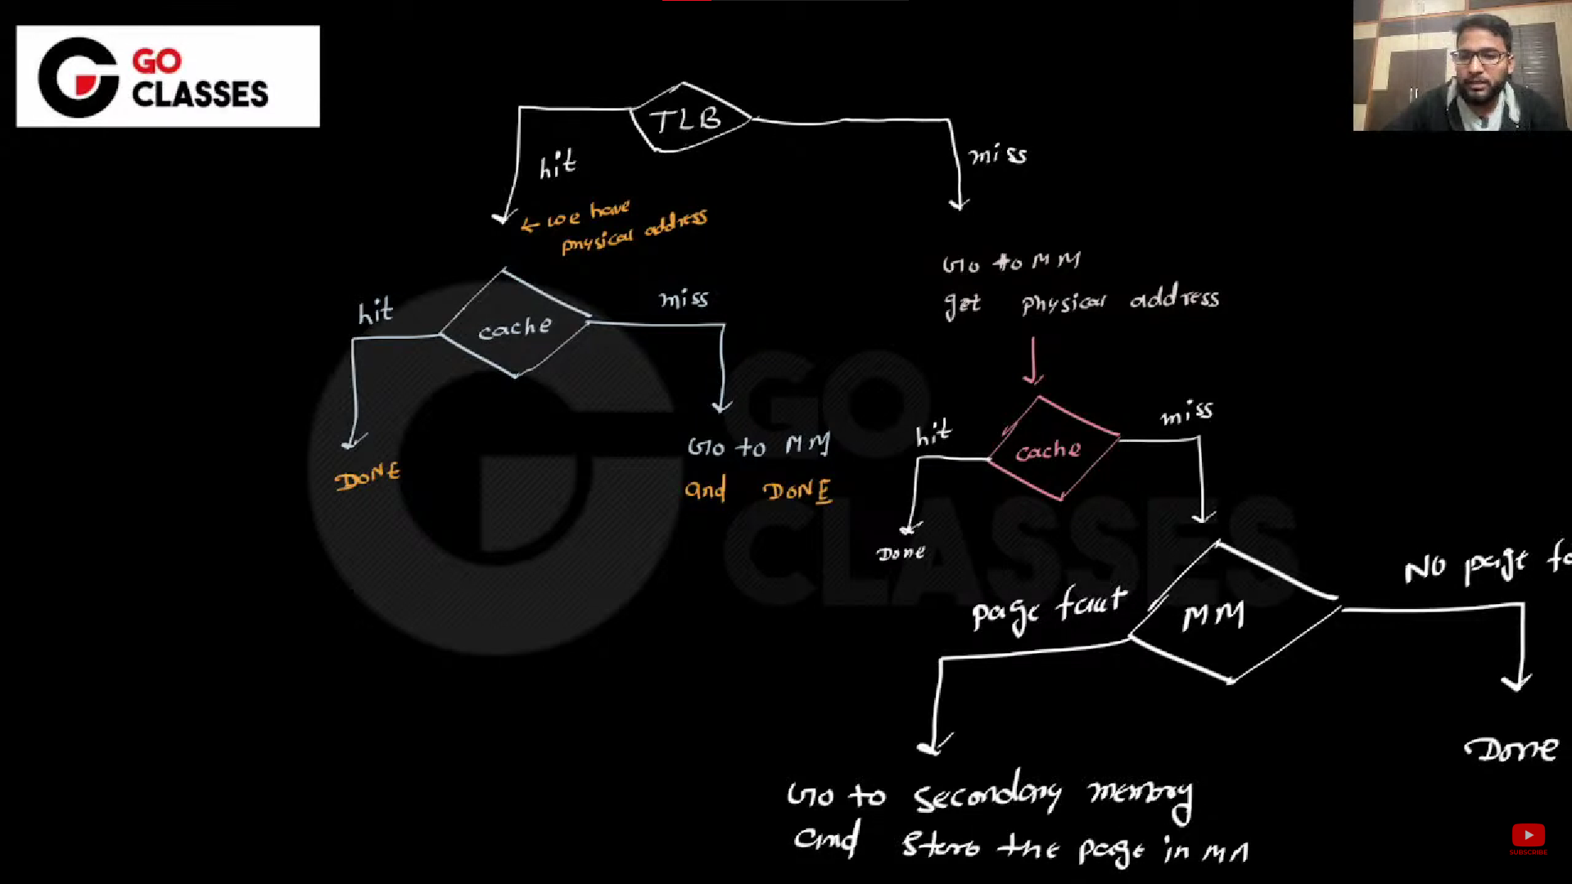

Q



Soln

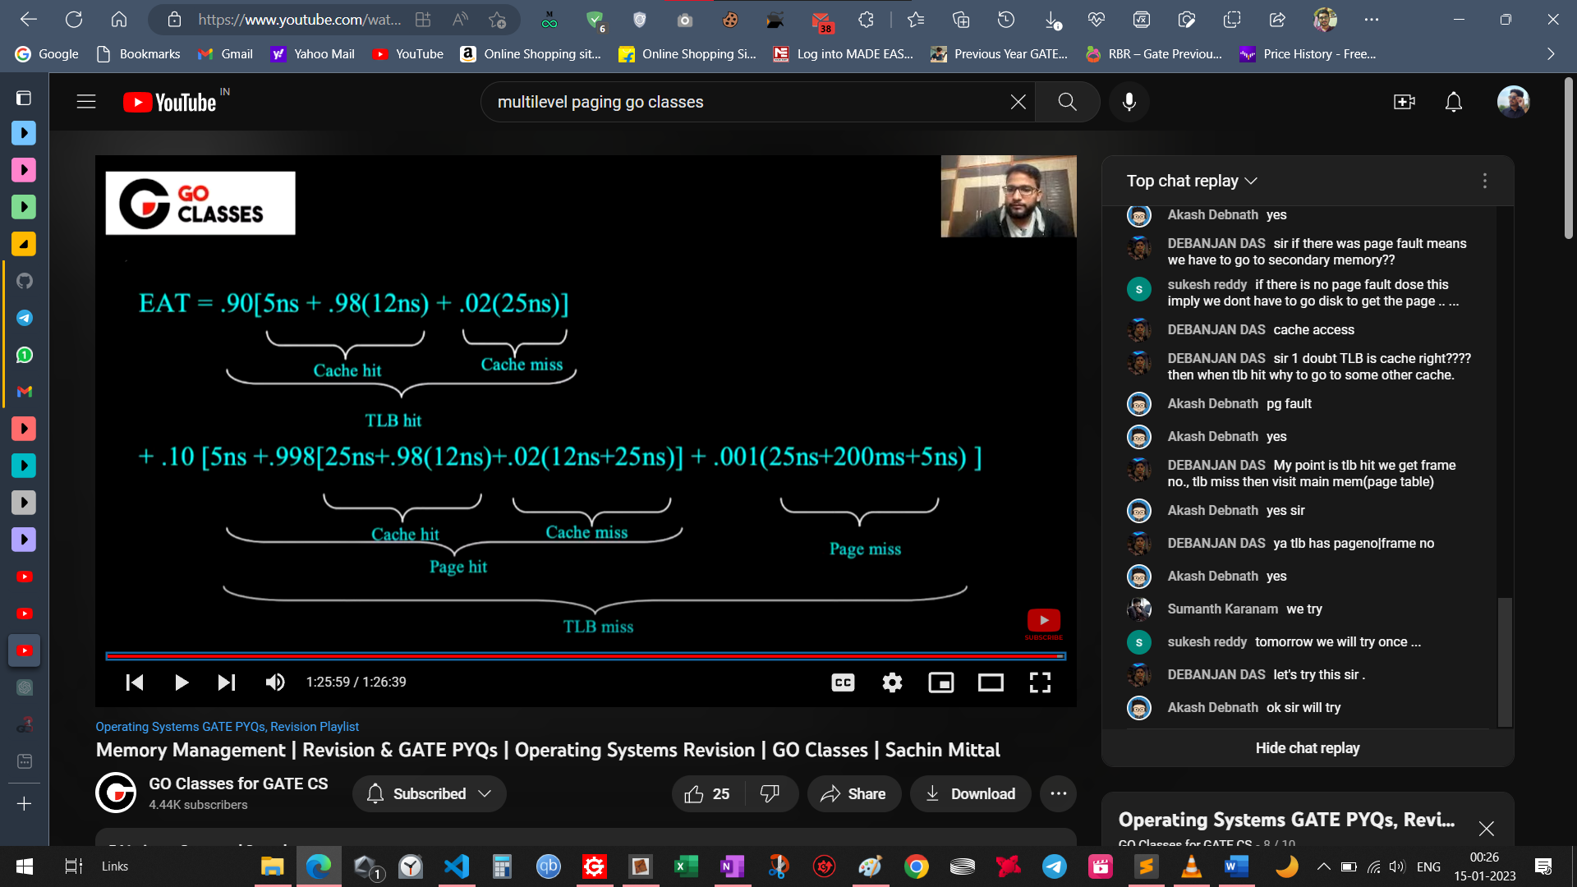

Q:

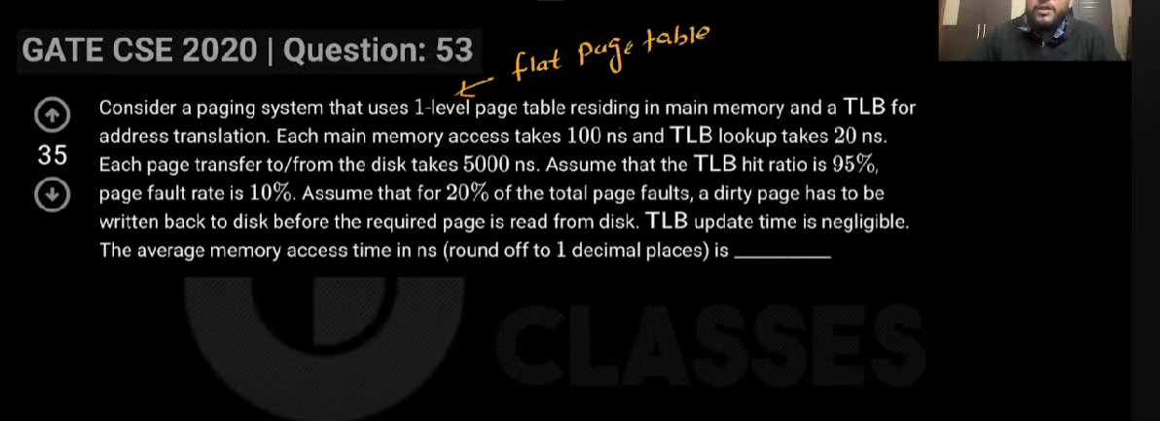

Soln: 